**Medical laboratory system database**

|  |  |
| --- | --- |
| name | ID |
| Sama hazem | 231002053 |
| Sara ahmed | 231000777 |
| Maria amgad | 231001529 |

**Introduction**

This project is a complete medical laboratory database system consisting of a structured Mysql relational schema. We designed and implement a database for medical laboratory system. The system facilitates the process ofstoring the data of laboratorian, patient, medical test, test results, component (materials) of tests.

**Conceptual design**

**Entities and Attributes**

The medical laboratory system consists of the following main entities along with their attributes:

* **Laboratorian**: Represents the staff who perform medical tests.  
  Attributes:
  + ID (Primary Key)
  + Name
  + Phone number
  + Address
* **Patient**: Represents individuals who undergo medical tests.  
  Attributes:
  + PatientID (Primary Key)
  + Name
  + Phone number
  + Address
  + Birth Date
  + Job
* **Component**: Materials or supplies used in conducting medical tests.  
  Attributes:
  + ComponentID (Primary Key)
  + Name
  + Available Quantity
  + Minimum Quantity
* **Medical Test**: The tests available in the laboratory.  
  Attributes:
  + TestID (Primary Key)
  + Name
  + Price
* **Test Result**: Stores the outcome of tests performed on patients.  
  Attributes:
  + TestID (Foreign Key referencing Medical Test)
  + Date (Date test was performed)
  + PatientID (Foreign Key referencing Patient)
  + LaboratorianID (Foreign Key referencing Laboratorian)
  + Result (Test outcome)

**Cardinality Ratios and Participation Constraints**

In the medical laboratory system, the relationships between entities are defined with specific cardinality ratios and participation constraints to accurately model the real-world scenario.

1. **Patient to Test Result**
   * **Cardinality:** One-to-many (1:N)  
     Each patient can have zero or more test results because a patient may undergo multiple medical tests over time.
   * **Participation:** Partial participation on Patient side, total participation on Test Result side  
     Not every patient necessarily has a test result recorded at all times, but every test result must be associated with exactly one patient.
2. **Laboratorian to Test Result**
   * **Cardinality:** One-to-many (1:N)  
     Each laboratorian can perform many tests, resulting in multiple test results associated with them.
   * **Participation:** Partial participation on Laboratorian side, total participation on Test Result side  
     Some laboratorians might not have performed tests yet, but every test result must be linked to one laboratorian.
3. **Medical Test to Test Result**
   * **Cardinality:** One-to-many (1:N)  
     Each medical test can be conducted multiple times, producing multiple test results.
   * **Participation:** Partial participation on Medical Test side, total participation on Test Result side  
     Not all medical tests may have been performed yet, but every test result must refer to exactly one medical test.
4. **Medical Test to Component**
   * **Cardinality:** Many-to-many (M:N), simplified here as One-to-many (1:N) for design clarity  
     Each medical test requires one or more components, and components can be used in multiple tests. For simplicity, in this design, each test is associated with one primary component.

**Participation:** Partial participation on both sides  
Some components may not be currently used in any tests, and some tests may use components not explicitly modeled here

**Relational schema**

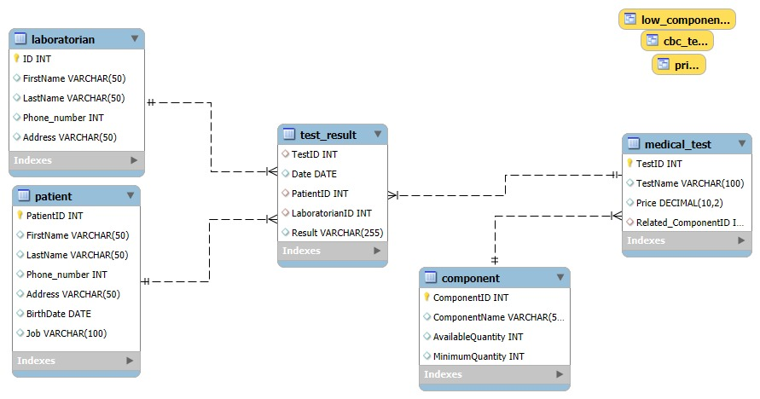

-Each entity is converted to a table with attributes and primary keys. Foreign keys ensure referential integrity between related tables. For example, Medical_Test references Component, and Test_Result references Patient, Laboratorian, and Medical_Test.

**- Queries with Screenshots :**

**- About schema**

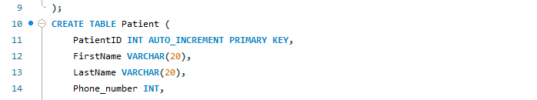

Each entity is converted to a table with attributes and primary keys. Foreign keys ensure referential integrity between related tables. For example, Medical_Test references Component, and Test_Result references Patient, Laboratorian, and Medical_Test.

**-. List the total money paid by a patient with ID 12527 in the last three years**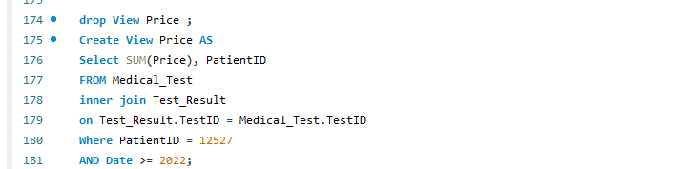

This view calculates the total amount of money paid by the patient with PatientID = 12527 for all tests taken since the beginning of 2022 by summing up the Price from the Medical_Test table.

**. List the names of components that are below the minimum quantity**



This query checks which test components have an AvailableQuantity that is less than the MinimumQuantity, indicating that those components need to be restocked.

**UI in database:**

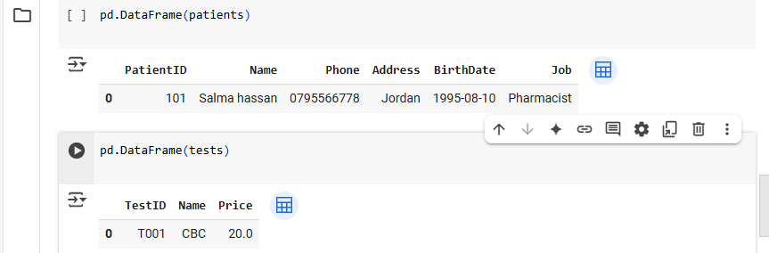

https://colab.research.google.com/drive/1GtHM_jImXUGhzHukm_w9KCdj4wezdPqZ?usp=sharing

An interactive interface (e.g., in Google Colab or a web app) can be built to add/view data dynamically, making the system user-friendly .